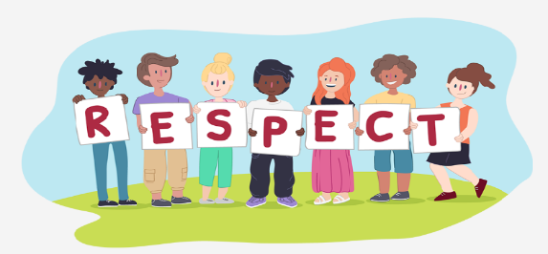

Show initiative.

Ask questions.

Problem solve and apply learning.

Try different methods and strategies.

Take ownership of your learning, development and environment.

Be well organised – plan ahead.

Wear the correct uniform and follow rules – be a positive role model.

Maintain a positive attitude: believe in yourself.

Have a growth mindset; persist and remain optimistic, even when it is difficult – don’t give up.

Recognise and manage feelings and emotions.

**Our Key Values**

**The 6 Rs**



Treat people the way you would like to be treated.

Show you care about yourself and other people’s feelings, wishes and rights.

Show understanding and tolerance – value other people’s similarities and differences.

Work collaboratively – take turns, share ideas – encourage each other; include and support others.

Recognise and celebrate each other’s achievements.

Show compassion and empathy.

Communicate effectively in different ways.



Look back and evaluate.

Learn from experience.

Make connections

Always ask ‘Is this the best I can do?’